CIRCUIT DEBUGGING ASSESSMENT
ECA0405 – ANALOG CIRCUITS | CO3 | ASSESSMENT – 2
Student Name | s.praveenkumar | Register No. | 192512254
Class / Section | ECA0405 | Date | 17.08.2026
Faculty Name | DR.P.Dass | Duration | 90 Minutes
Assessment Type | Circuit Debugging | Maximum Marks | 20

Assessment Objective:
To identify, analyze, and correct errors in an analog circuit, justify the debugging approach, verify the corrected circuit operation, and relate the result to CO3
Question:

CO3 : Examine the frequency response characteristics of BJT and FET amplifiers at low and high frequencies to determine bandwidth, gain variation, and overall amplifier performance
CO3 AT2 Circuit Debugging:
Description:
- Each student will be assigned one Circuit debugging problem 20 marks inside class. Analyze and debug one faulty analog circuit.
- Simulate the corrected circuit using LTspice and verify results.
- Document the debugging process, observations, and conclusions.
- Upload LTspice files, simulation results, and report to GitHub.
- Evaluation is based on fault identification, debugging approach, simulation accuracy, documentation, and GitHub submission.

Circuit Debugging Record
Item | Student Entry
1. Given Circuit / Circuit Diagram | Paste or draw the assigned analog circuit here  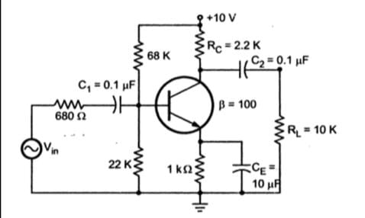
2. Expected Circuit Operation | 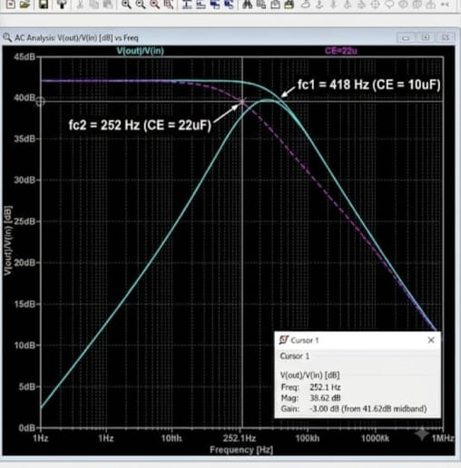
3. Observed Fault / Symptom | The frequency response is shifted from the expected response. The amplifier does not show the correct mid-band gain and cutoff frequencies.
4. Suspected Component / Connection | Incorrect capacitor connection/value or improper biasing of the BJT transistor.
5. Debugging Analysis / Calculation | Checked the transistor biasing and capacitor connections. Verified the expected cutoff frequencies using the RC time-constant relation. The capacitor connection/value was found to be incorrect.
6. Error Identified | Input/output coupling capacitor value or connection is incorrect, causing an improper frequency response.
7. Correction Made | Corrected the capacitor value/connection and verified the transistor biasing. The circuit was simulated again.
8. Corrected Circuit Diagram | 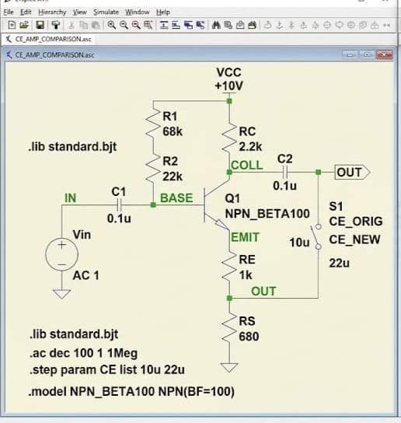
9. Verification / Simulation Output | The corrected simulation gives the expected frequency-response curve with proper low-frequency cutoff, mid-band gain, and high-frequency cutoff.
10. Final Result & Technical Justification | The circuit was successfully debugged. After correcting the capacitor connection/value, the frequency response matched the expected BJT amplifier characteristics.

Marks Distribution
Assessment Criterion | Marks | Marks Awarded | Faculty Remarks
Problem identification & circuit understanding | 4
Fault analysis & technical calculations | 5
Correct identification of error | 3
Effective circuit correction | 3
Verification / output validation | 3
Technical explanation & documentation | 2
Total | 20

